## horizontal line

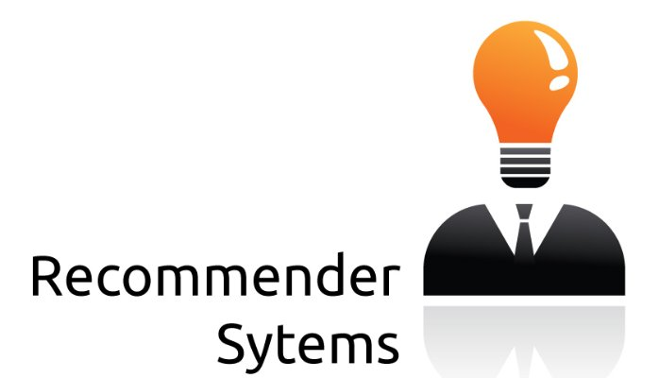

22.03.2017

Team:

1. Yash Gangrade 13116074 B.Tech 4th year ECE
2. Sanyam Rajpal 15116051 B.Tech 2nd year ECE
3. Deepika Sharma 15113038 B.Tech 2nd year EE
4. Lakshya Gaba 15115073 B.Tech 2nd year EE

# Introduction

As students are bombarded with a new dilemma of selecting open electives and departmental electives, it starts reminding them of their old adventure with college selection during their JEE times. Having no or very little idea about what the course contains, it becomes extremely hard to boil down their choices. This eventually leads to students following herd mentality and choosing courses similar to their friends with no real introspection. It usually results in backfiring as they are not able to enjoy the curriculum of the elective and do something considerable thus defeating the whole purpose of electives. We decided to develop a system which will help students regarding this and several other issues.

# Solution

# To assist students in selecting appropriate courses, we propose a solution of recommending elective courses to them according to their past experience and similarity with other students. The system strongly recommends a course that is necessary for a student to graduate that is core to the university curriculum and that the student is expected to succeed in academically. Every student is asked to rate the courses he/she has done in previous semester at the time of registration. The next semester courses will be recommended using content-based and collaborative techniques. The algorithm identifies other students with similar tastes to a targeted student and combines their ratings to make recommendations for that student.

# Method

We have developed a web portal where any user can login using his/her ID and Password. Then he/she may ask for a recommendation based on the elective available and the system will automatically show the results by comparing them to existing profiles. At the time of one time registration, a user is asked to rate all the courses he/she has done till this semester and based on this, recommendation can be made. Though being a simple idea it can help several students for this everlasting dilemma.

**Resources used:**

* HTML. CSS, JavaScript – for front end
* Django framework, Python, SQL3 – for backend
* Libraries for Matrix Factorization Method & Pearson Method

**Future Prospective**

There are innumerable areas in this project that be implemented:

* As there are numerous events that are happening in a cultural or technical fest of college, sometimes students miss some events that would have been useful for them. Using this system, we can help them in creating an optimal schedule.
* It can also help students to find contacts of appropriate individuals if a student need help regarding different things like research internships, start-up, academic projects etc.
* Similarly, we can help them in recommending which campus groups to target for, what books to study, different resources recommendation etc.